|  |
| --- |
|  |
| Scrolling Space Shooter |
| Java III Term Project |
|  |
| **Matt Kolton** |
|  |

|  |
| --- |
|  |

**Introduction**

The scrolling shooter will be an arcade-style shooter game in which the player moves around in a designated space in the bottom of the screen and shoots at enemies that fly in to attack. There will be multiple classes of enemies as well as power-ups for the player.

**Description**

The game will have different enemies that move at different speeds, have different weapons, or have different amounts of health. Power-ups for the player will include different weapons that deal more damage and/or have a larger area of effect, as well as extra lives and shields. Enemies will enter the screen randomly, and there will be a maximum number on the screen at one time, which is determined by the level. At the end of the level, there will be a boss fight.

The graphical user interface will display the player’s lives and health, the current level, the score, and any other useful information such as the currently equipped weapon.

**Timeline**

**Player**

Create a player that can move around the designated space at the bottom of the game screen and fire its weapon.

**Enemy**

Create enemies that spawn randomly, enter the screen from the top rather than suddenly appearing, and randomly fire their weapons.

**Shot Listening**

Make weapons affect players and enemies correctly.

**GUI**

Create a graphical user interface that will display information.

**Enemy Classes**

Create different classes of enemies and their different behaviors

**Power Ups**

Create power ups that affect the player correctly

**Levels**

Create levels that end when the player defeats a certain number of enemies. Make the number of enemies increase with the level and increment the level when it’s completed.

**Boss Battles**

Create bosses and have them appear at the end of the level. Give them high health and different attack patterns.

**Prototypes**

Rough prototype of the general look: the player is on the bottom with enemies firing from the top. The left side of the screen will be used for the GUI

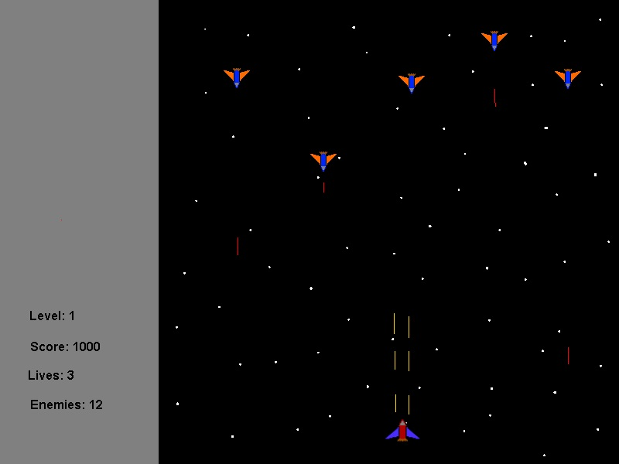

Boss battles will be one-on-one against much bigger and stronger enemies

